Microwaved water
Introduction
A study claims to have found that plants watered with water that was boiled in a microwave died. But ones given normal boiled water thrived. We want to test whether that claim is true: Does microwaving water do something that kills plants?
Method
We set up……
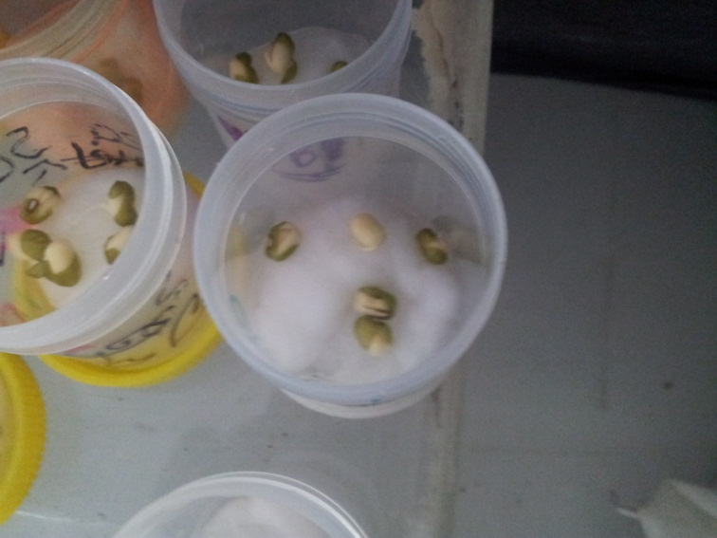
We changed……
Things we kept the same……

Results
And look at what happened
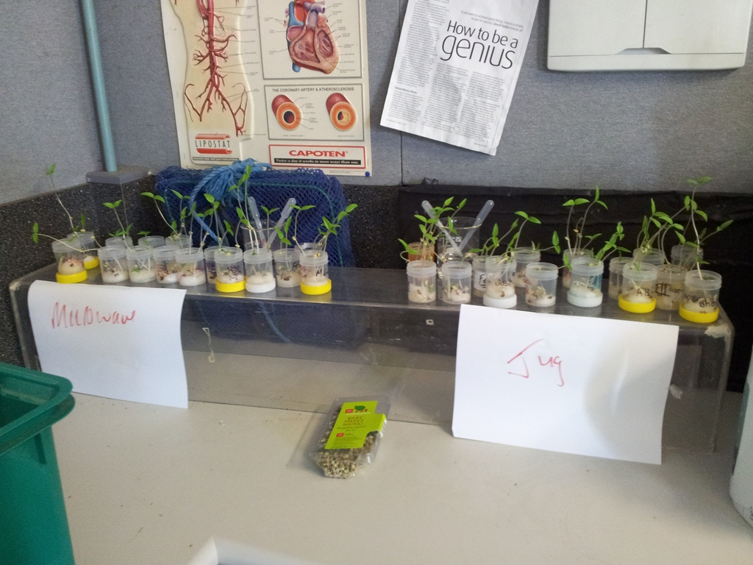
 | Plant survival |  |  |  | Plant height (cm)
 | microwave | jug |  |  | microwave | jug
 | 69.2 | 68.6 |  |  | 17 | 16
Conclusion
Well then what do these graphs tell us about the danger of using microwaved water….

