People
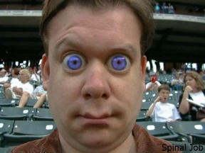
In people brown eye colour (B) is the dominant trait & blue (b) is recessive

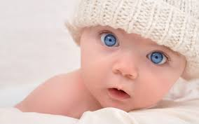
1 These two have a kid that looks like ….

Explain this…
If blue is recessive then the man must be …. BB, Bb or bb (circle correct one) we know this because:
If he had any … ____________________________________________________________
So the dad must always pass on a ____allele
The baby also has blue eyes so must also have the alleles ________
For the baby to get those alleles the mother must be BB, Bb or bb (circle correct one)
The mum can’t be bb because then she would have______________________
If the mum was BB then she would always pass on a ___ allele and the baby would have _______
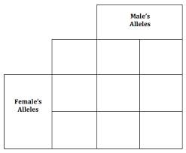
So the mum must be ____ so that she can pass on a ____

2 Explain this…
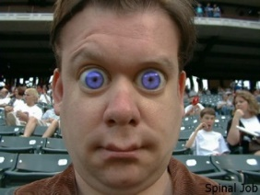
Produce this kid

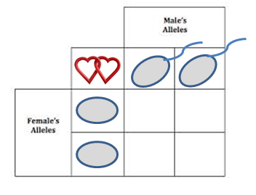

____________________________________________________________________________
____________________________________________________________________________
3 Explain this….
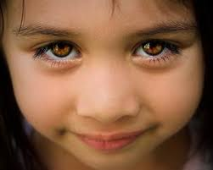
Produce this kid

____________________________________________________________________________
____________________________________________________________________________
4 Explain this….
Produce this kid

5 could this happen …
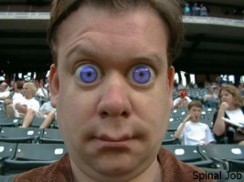
Produce this kid

____________________________________________________________________________
____________________________________________________________________________

