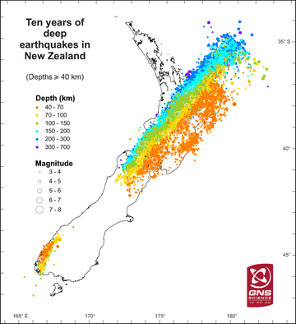
Plates and stuff
On the map:
- Draw the plate boundaries
- Label the plates
- Annotate to show the info on the handout (p136)

