Name:

Nayland College

Year 10 Science

GENETICS practice Test

Time allowed: 1 period

Instructions:

Read all questions carefully

Complete all answers in the spaces provided

If extra space is needed use the final page.

Achievement Criteria | For Assessor’s use only
Achievement | Achievement  with Merit | Achievement  with Excellence
Overall Level of Performance

- In the bear, white ears (w) is recessive to brown ears (W).

- What is the genotype of a bear with white ears?

- What is the phenotype of the bear with Ww?

- In the grid provided, predict the phenotype results of a cross between heterozygous brown eared bear and a white eared bear.

Phenotype results:

- In cats, long hair is the result of a dominant gene (L), and short hair is the result of the recessive gene (l). A long haired female cat is mated with a short haied male, and produces a litter of 3 long haired and 5 short haied kittens.

- Give the genotype of each parent. female male

- In theory, how many of the 8 kittens produced were expected to be long haired?

- The gene for long hair is said to be DOMINANT. Explain what this means.

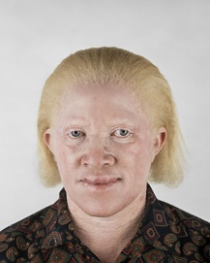
- Albinism, the total lack of pigment in the skin is due to a recessive gene. A man and a woman plan to marry and wish to know the probability of having any albino children. Use punnet squares to show what you would tell them if:

An African Albino

- The man and woman are both normal but both have fathers who are albino
Use (a) for albino and (A) for non-albino

- The man is albino and the woman is normal from a family with no known albinos in it.

- The family tree shows people who can roll their tongues in a family.

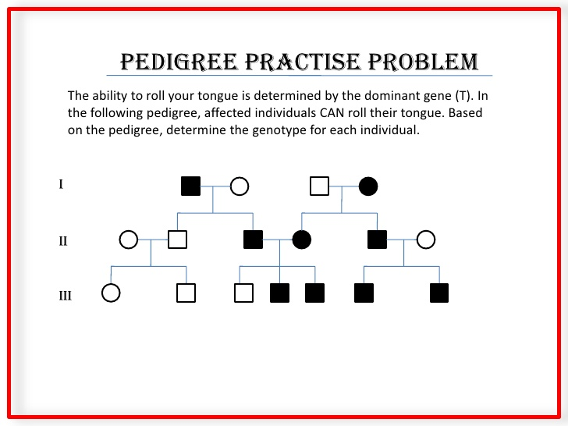
black = tongue roller white = not a tongue roller

Square = male circle = female

Which individual (circle on the tree) shows that NOT being able to tongue roll is a recessive trait? Why?

Scientific Information

A normal human body cell has 46 chromosomes in its nucleus.
Sperm cells and egg cells are made during a process called MEIOSIS.
A zygote is formed when a sperm cell joins with an egg cell.

- Complete the table

A Number of chromosomes in the sperm
B Number of chromosomes in the egg
C Process of egg and sperm joining
D Number of chromosomes in the zygote

MEIOSIS
egg
C
Human body cells
46
sperm
B
A
D
zygote
46

