Location of previous sites, 2EMS & MM2…. Point 3 on map

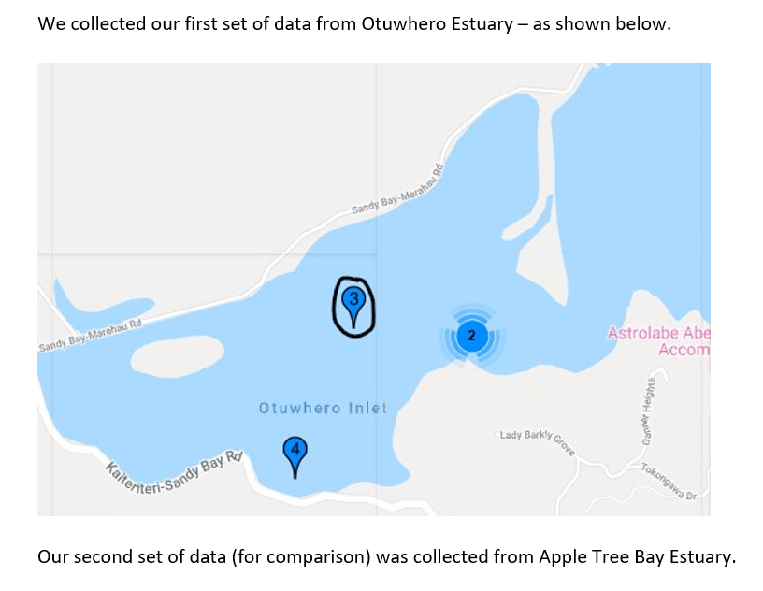

Class of 2019 data:

Q 
Q 
Q 

Mm2 data from 2018 at site 3 above

