Q2 Does the current site swapping proposal offer a significant opportunity for New Zealand Salmon farming in managing its environmental footprint. Discuss.

The 2017 MPI report from the Marlborough Salmon Farm Relocation Advisory Panel proposes that six existing salmon farm sites should be decommissioned and that six new sites should be developed (Industries, n.d.-d). The maps below (Figures 1 & 2) show the locations of the existing and proposed new sites. The new sites being: Blowhole Point North, Blowhole Point South, Waitata Mid-Channel, Horseshoe Bay and Richmond Bay South in Pelorus Sound and in Tory Channel, Tio Point. MPI proposes to close sites in a staged process in the order: Ruakaka, Otanerau, Waihinau Bay, Forsyth Bay and Crail Bay.
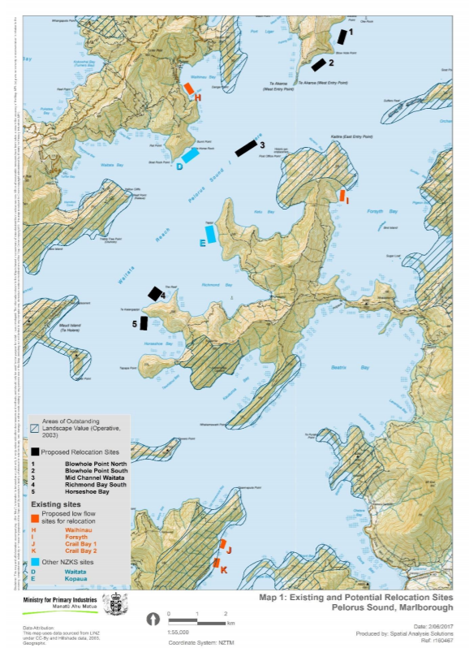
Figure 1
From: Marlborough Salmon Farm Relocation Advisory Panel Report
Figure 2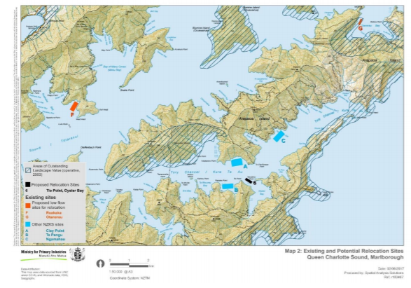
From: Marlborough Salmon Farm Relocation Advisory Panel Report

The question is, why relocate sites? Primarily the reason is that several sites currently being farmed in the Marlborough Sounds are in inappropriate locations and this has resulted in significant environmental degradation, mostly of the benthic community directly under the cages. An Enrichment Scale (ES) (Figure 3) has been developed to measure this impact (Industries, n.d.-a).
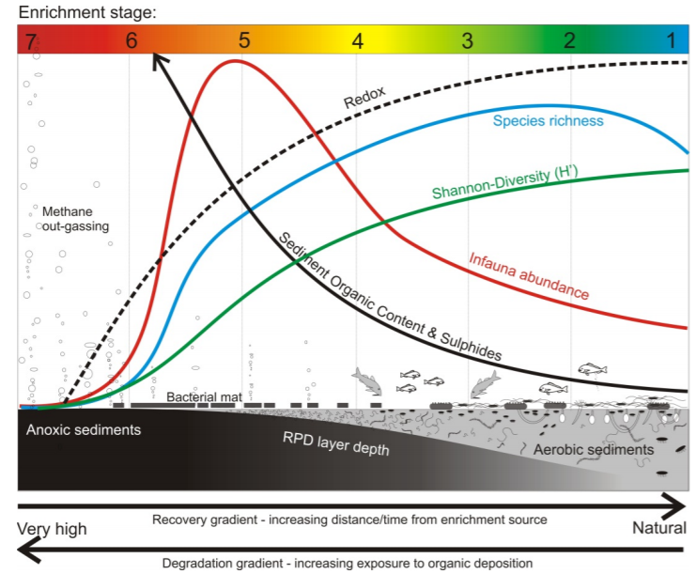
Figure 3
From: Best Management Practice guidelines for salmon farms in the Marlborough Sounds

ES 5 has been set as the maximum level of impact for a salmon farm directly beneath the cages and ES 3 at the outer limits of the effects of the farm. At ES 5, species diversity has declined and worms and nematodes dominate. At levels exceeding ES 5 serious degradation occurs with depleted oxygen, increased sulphides and an anoxic environment unsuitable for most marine invertebrates, and potentially problematic for the fish. The causes of benthic degradation are uneaten food and faeces dropping onto the seabed resulting in organic enrichment (James, Hartstein, & Giles, n.d.), (MacLeod, Crawford, & Moltschaniwskyj, 2004). In 2017 four sites in the Marlborough Sounds would be non-compliant, by exceeding ES 5 (Industries, n.d.-d).
Currents disperse the organic waste and so impacts decline moving away from the area directly under cages (Figure 4). The shallow, low flow sites such as Ruakaka and Forsyth (potentially smolt rearing only) have been shown to be most damaging (Industries, n.d.-b) and are therefore the sites identified for the first stage of relocation. Along with relocation MPI proposes to adopt an adaptive management regime where feed levels will be incrementally increased only when monitoring shows ES5 (inner areas) and ES3 (outer areas) are not exceeded (Industries, n.d.-d)

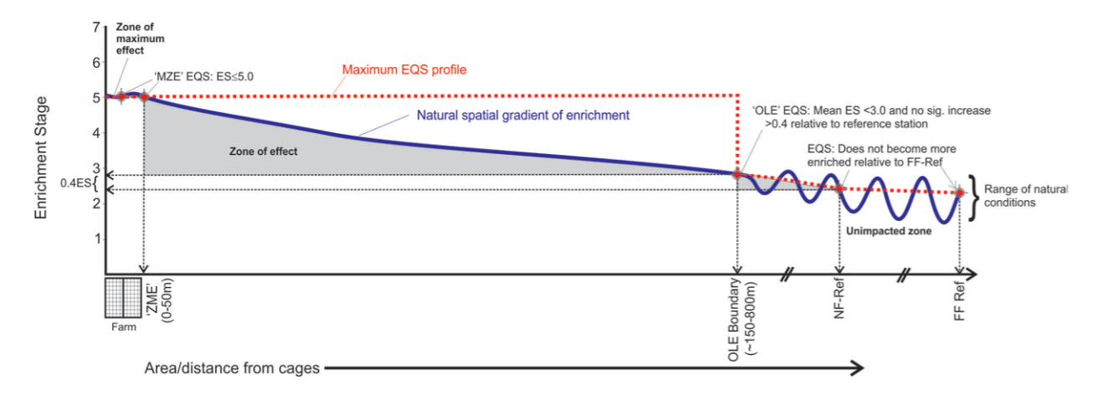
Figure 4
From: Best Management Practice guidelines for salmon farms in the Marlborough Sounds

Relocating sites not only has the potential to reduce environmental impacts but it will also benefit the farms economically. King Salmon report that their low flow sites have poorer FCR and higher mortality than their higher flow sites, making them less profitable (“NZK-1H17-Results-Presentation.pdf,” n.d.), see also figure 5.

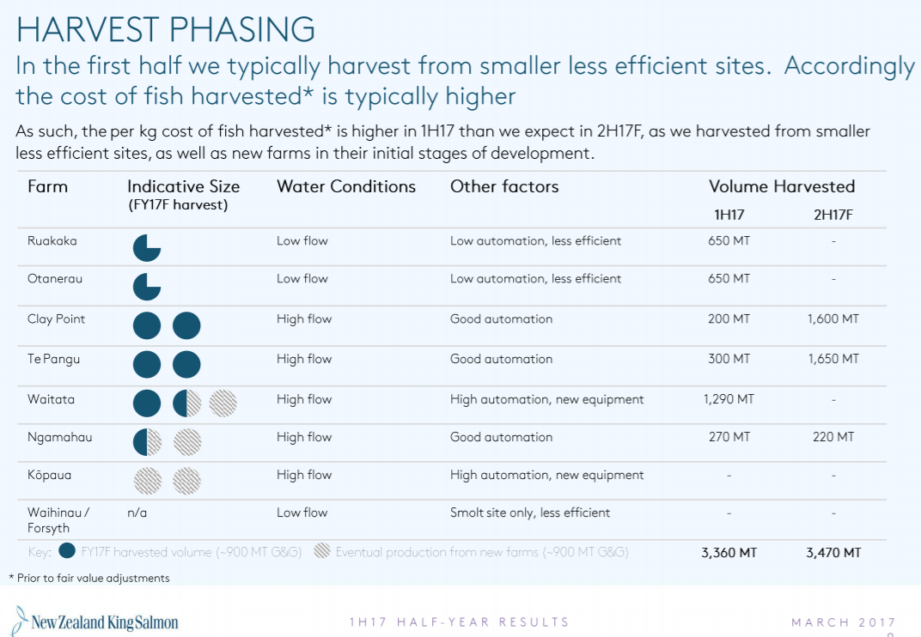

Figure 5 King Salmon Harvest 2017
From: NZ King Salmon Highlights

While relocating to higher flow sites is likely to reduce the benthic environmental footprint of the farms there are some possible “fish hooks”. A peer review of NIWA’s assessment raised concern that the new sites have strong currents (up to 30cm/s) and would thus be highly dispersive, spreading organic waste over a large area (Industries, n.d.-c). While this is the point of moving to high flow sites it was recognised that there is the potential for “hot spots” to develop where current flows suddenly reduce and waste could then fall in a narrow area (Industries, n.d.-c). Ongoing and extensive monitoring will be required to ensure the new sites are appropriately located to avoid such “hot spots”.
While site swapping does provide the opportunity to reduce benthic impacts, of even greater benefit would be having sufficient sites to allow for crop rotation and fallowing. Overseas studies have shown that leaving degraded sites fallow does lead to the benthic community recovering (Brooks, Stierns, & Backman, 2004). Full recovery of the benthos directly under sea cages is likely to take years. However, the impacted zone away from the cages can show significant recovery after a few months (MacLeod et al., 2004). This has also been reported for sites in the Marlborough Sounds (Keeley, Forrest, & Macleod, 2015). Another option could involve the vacuum removal of deposited organic material. However, it is unclear whether that strategy would have an overall positive effect and King Salmon favour natural remediation until it is shown whether vacuum removal is beneficial (Industries, n.d.-d). The plan to relocate the Otanerau farm to Tio Point, the Waihinau Bay farm to South Richmond, and the Ruakaka farm to Horseshoe Bay, is confidently expected to enable salmon farming at the new high-flow sites with direct benthic impacts under all operating salmon farms maintained below ES 5 (Industries, n.d.-d).
Benthic degradation is not the only impact of salmon farm operations. Significant nutrient enrichment also occurs (“ae01environimpact.pdf,” n.d.). Figure 6 shows the predicted nitrogen load to the water column for an Atlantic Salmon farm in Scotland. The situation would be of a similar magnitude for the Marlborough salmon farms. This nutrient enrichment has the potential to cause phytoplankton blooms, including toxic and nuisance species. This has contributed to considerable opposition to King Salmon’s operation in the past.

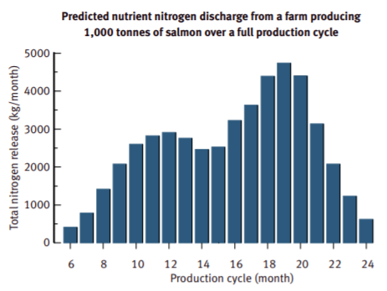
Figure 6 Nitrogen release from a salmon farm
From: Fisheries Research Services, Scotland

While moving some of the existing farms in the sounds to high flow sites makes sense with respect to benthic impacts it will not reduce the overall level of nutrients released, but nutrients would be dispersed and diluted more. So, the question is, what is the impact of elevated nutrients? According to modelling studies carried out by Cawthron the impact would be “less than minor” (Industries, n.d.-d). Studies carried out in Stewart Island back up this view where it has been reported that N inputs from the salmon farms (over a 20 yr period) have not lead to an increase in phytoplankton and that the problems experienced in the past with algae blooms causing mass mortality were due to natural La Nina conditions (James et al., n.d.).

Under the rules of the New Zealand Coastal Policy Statement 2010, any marine farming operation must take a precautionary approach with respect to endangered wildlife. It so happens that this applies to the existing and proposed sites. King Shags (see figure 7) are an endangered species restricted to the Marlborough Sounds, at only 839 birds they are one of the rarest seabirds in the world (“Rare King Shag survey results | New Zealand King Salmon,” n.d.). King Shags are prone to disturbance from human activities (Industries, n.d.-d). King Salmon has been working with DoC and local iwi and have a management plan in place. 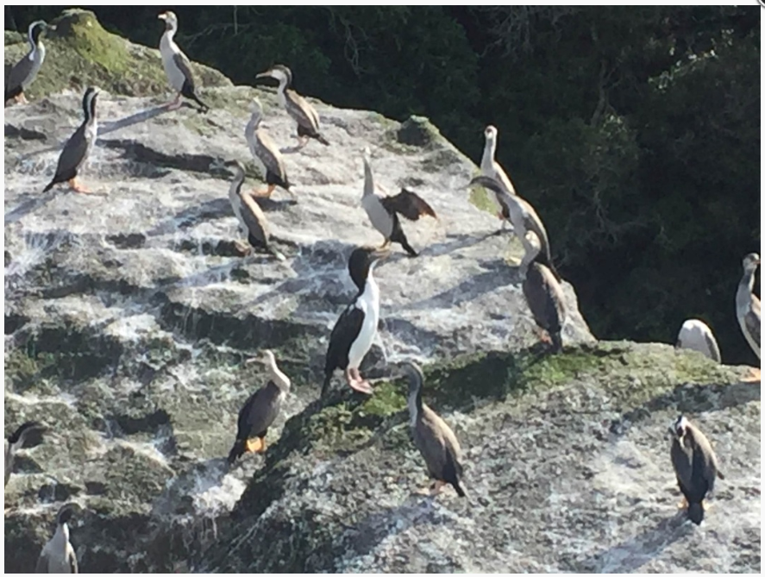
Figure 7 King Shag (the big one in the centre with pink feet)
Photo credit: Graeme Bloomfield
Note: I am not sure if the 839 includes this one we often see on Adelle Island, maybe there are 840 of them.
In the sounds the major King Shag roosting colonies are near Forsyth and the Trio Islands with birds foraging in the outer sounds and the Northern Pelorus areas. Of the proposed new sites Tio Point is outside the foraging area while Blowhole North, Blowhole South, and Waitata Reach Mid-Channel are within the range of the birds. Two other sites (Richmond Bay South and Horseshoe Bay) are near the limit of their range. Relocating the Ruakaka, Otanerau and Waihinau farms is likely to be beneficial to the population of King Shags as the disturbances caused by farming operations there will be removed and the new sites are far enough away so are unlikely to impact on the birds.
A further environmental impact caused by salmon farming was particularly noticed this summer where considerably higher than normal sea water temperatures (“Climate Summary for January 2018,” 2018) caused the loss of over a thousand tonnes of salmon (“NZ King Salmon to finish fiscal year nose up, despite heat-related fish deaths,” n.d.). These fish have to be disposed of and currently the only option has been to send the dead fish to landfill (“Thousand tonnes of dead fish poses problem for King Salmon,” 2018). While this practice does not create an environmental issue for the marine area there is nevertheless an impact on the terrestrial environment. Given that the sites that suffered the worst mortality were the shallow, low flow sites tagged for removal (especially Ruakaka) then moving these to deeper higher flow sites is likely to have a positive environmental outcome through needing to dispose of fewer mortalities.
One final benefit of relocation of farms to high flow sites concerns the threat of disease. In 2012 high mortality at the low flow Waihinau site was initially attributed to sub-optimal environmental conditions. However, testing showed diseased fish were infected with rickettsia-like agent (NZ-RLO) and the endemic opportunist bacterium Tenacibaculum maritimum (Industries, n.d.-e). This outbreak at the low flow site in Waihinau Bay highlights the increased risk of disease emergence in fish cultured at suboptimal sites (Industries, n.d.-e). Removing sub-optimal low flow sites in favour of deeper, higher flow sites reduces the risk of outbreaks of infectious diseases and the spreads to wild populations (Industries, n.d.-e).

In summary the proposal to swap poorly sited farms for deeper, high flow sites does offer the industry a significant opportunity to manage and reduce the environmental footprint of salmon farming. This will come about by:
- reducing benthic degradation due to organic waste build-up
- reducing the possible (although unlikely) impact of nitrogen in the water column
- reducing the impact on King Shags by moving the operations away from roosting and foraging areas
- reducing the number and thus impact of mortalities caused by high temperature stress
- reducing the risk of disease outbreaks.

Seems a no-brainer. Of course global warming may have the final say by making salmon farming in the sounds not viable in the long term.

References

ae01environimpact.pdf. (n.d.). Retrieved from http://www.gov.scot/uploads/documents/ae01environimpact.pdf
Brooks, K. M., Stierns, A. R., & Backman, C. (2004). Seven year remediation study at the Carrie Bay Atlantic salmon (Salmo salar) farm in the Broughton Archipelago, British Columbia, Canada. Aquaculture, 239(1), 81–123. https://doi.org/10.1016/j.aquaculture.2003.12.024
Climate Summary for January 2018. (2018, February 1). Retrieved June 18, 2018, from https://www.niwa.co.nz/climate/monthly/climate-summary-for-january-2018
Industries, M. for P. (n.d.-a). Download “Best Management Practice guidelines for salmon farming in the Marlborough Sounds” | MPI - Ministry for Primary Industries. A New Zealand Government Department. Retrieved July 1, 2018, from https://www.mpi.govt.nz/dmsdocument/15994/loggedIn
Industries, M. for P. (n.d.-b). Download “Literature Review of Ecological Effects of Aquaculture, Chapter 1 Introduction” | MPI - Ministry for Primary Industries. A New Zealand Government Department. Retrieved June 14, 2018, from https://www.mpi.govt.nz/dmsdocument/3749/loggedIn
Industries, M. for P. (n.d.-c). Download “Peer review of NIWA assessments of benthic effects of relocation of salmon farms in the Marlborough Sounds” | MPI - Ministry for Primary Industries. A New Zealand Government Department. Retrieved July 2, 2018, from http://www.mpi.govt.nz/dmsdocument/16120/loggedIn
Industries, M. for P. (n.d.-d). Download “Report and Recommendations of the Marlborough Salmon Farm Relocation Advisory Panel” | MPI - Ministry for Primary Industries. A New Zealand Government Department. Retrieved July 1, 2018, from https://www.mpi.govt.nz/dmsdocument/27447/loggedIn
Industries, M. for P. (n.d.-e). Download “Updated disease risk assessment report - relocation of samon farms in Marlborough Sounds - prepared by Digfish Services” | MPI - Ministry for Primary Industries. A New Zealand Government Department. Retrieved July 2, 2018, from https://www.mpi.govt.nz/dmsdocument/16048/loggedIn
James, M., Hartstein, N., & Giles, H. (n.d.). Assessment of ecological effects of expanding salmon farming in Big Glory Bay, Stewart Island – Part 2 Assessment of effects, 45.
Keeley, N. B., Forrest, B. M., & Macleod, C. K. (2015). Benthic recovery and re-impact responses from salmon farm enrichment: Implications for farm management. Aquaculture, 435, 412–423. https://doi.org/10.1016/j.aquaculture.2014.10.007
MacLeod, C. K., Crawford, C. M., & Moltschaniwskyj, N. A. (2004). Assessment of long term change in sediment condition after organic enrichment: defining recovery. Marine Pollution Bulletin, 49, 79–88. https://doi.org/MacLeod, CK, Crawford, CM and Moltschaniwskyj, NA 2004 , 'Assessment of long term change in sediment condition after organic enrichment: defining recovery' , Marine Pollution Bulletin, vol. 49, no. 1-2 , pp. 79-88 , doi: 10.1016/j.marpolbul.2004.01.010 <http://dx.doi.org/10.1016/j.marpolbul.2004.01.010>.
NZ King Salmon to finish fiscal year nose up, despite heat-related fish deaths. (n.d.). Retrieved July 2, 2018, from https://www.undercurrentnews.com/2018/06/06/nz-king-salmon-to-finish-fiscal-year-nose-up-despite-heat-related-fish-deaths/
NZK-1H17-Results-Presentation.pdf. (n.d.). Retrieved from https://king-salmon-sarpzqh.stackpathdns.com/kingsalmon/wp-content/uploads/2016/10/NZK-1H17-Results-Presentation.pdf
Rare King Shag survey results | New Zealand King Salmon. (n.d.). Retrieved July 2, 2018, from https://www.kingsalmon.co.nz/news/rare-king-shag-new-survey-method-provides-most-accurate-count-to-date/
Thousand tonnes of dead fish poses problem for King Salmon. (2018, May 15). Retrieved July 2, 2018, from https://www.radionz.co.nz/news/national/357367/thousand-tonnes-of-dead-fish-poses-problem-for-king-salmon

