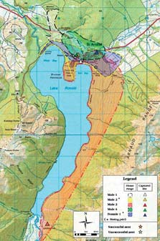
HUMAN FOOTPRINTS
Mainland Island and Its boundaries
Mainland Islands are relatively new ideas that are aiming to protect conserve and restore natural habitats through intensive management of pests. The idea of the ‘Island’ is to create boundaries around an area in order to reduce or eliminate chance of reinvasion of pests. Boundaries such as fences can be used to isolate an area but in Rotoiti the mainland Islands boundaries are natural geographical features and they have intensive pest control in the boundaries of this island.
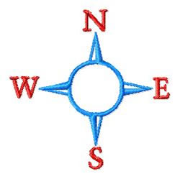
The mainland island at Rotoiti is all about science research and learning. The mainland island is beech forest and the protected area in 1997 was 825 hectares later in 2001 was expanded to cover 5000 hectares. Expanding was partly due to Kaka feeding nearby and they wanted to protect them. The boundaries are shown in the picture on the left, the area highlighted in orange is the area of which the mainland island is, the lake, ridgeline and Trevor’s river all act as natural boundaries, meaning there is no fence. Because there is no fence reinvasion occurs all the time and birds are free to leave. There are a lot of trap lines set around these boundaries to catch pests as they enter the Island.
The Lake acts as good boundary as it is unlikely pests will be able to swim across and enter the Island from the water. The mainland island only goes halfway up the hill and the ridgeline works well as the pests tend not to live on farmland as heavily as they do in forest and aren’t as likely to come from this area. Trevor’s river is also a body of water pests are unlikely to swim across.
The idea of the Mainland Island ( AIM ) is to restore lake Rotoiti to as close to its original state as possible, and too sustain populations of native birds and animals in the area. They can track how their pest control is going by comparing to a core area at Lake Rotorua which undergoes no pest control.

The ecological system.
Conserving the native species within the forest ecosystem is a new conservation strategy in New Zealand. The Rotoiti Mainland Island project is aiming to return the Beech forest to as close as possible as its original state, they start by looking at the Beech Tree ecosystem.
The Beech tree forest contains many different food sources, a primary one being the Beech scale insect (Ultracoelostoma assimile) which provides the honey dew that many different native species eat. Beech trees get their food from the sunlight and nutrients in the soil. The Beech scale insects in turn burrow into the Beech tree and live of the trees nutrients, in turn producing a high energy food, honeydew. Millions of these insects can be within just a hectare of forest and provide this abundant food source. (NZ has five different Beech Tree species which each prefer different living conditions,)
- Hard Beech (Nothofagus truncata) and black beech (Nothofagus solandri) are found in the lowland areas of the North Island and northern South Island.
- Red beech (N. fusca) prefers the foothills and inland river valley floors particularly where soils are fertile and well drained. Silver beech (N. menziesii) prefers higher, wetter conditions.
- Silver beech is the most widespread tall tree in Fiordland.
- Mountain beech (N. solandri var cliffortioides) grows in the mountains and on less fertile soils than silver beech, often forming the tree line at high altitudes.
http://www.doc.govt.nz/conservation/native-plants/beech-forest/
Honeydew eating birds are called nectar feeders, E.G Kaka, Tui, And Bellbird. In turn these birds then become a food source for the New Zealand Falcon.
The introduction of pests has disrupted the forest ecosystem by becoming part of the food web. Competition of food is a big thing as the possums and deeers have eating the berries, leaves and shrubs that the birds and other native invertebrates eat. The wasps feed on the honeydew and this is causing the nectar feeding birds to have less food. Even further Stoats, Rats, Cats, Possums and hedgehogs predate native animals in the food web.
A question I asked Doc worker Patrina Carter when in Rotoiti was, why does Doc protect these birds, and what do they do for the ecosystem? Well Birds are needed to keep the forest healthy, the spread of tree and other plant seeds are due to birds eating these seeds or flowers and later excreting the solid seeds somewhere else in the forest where they can then germinate and the tree species can spread. There will be a healthy forest if there is a high amount of birds.
Land use in Rotoiti.
In the past people burned down forest for farm land and mining in 1916, which destroyed habitats for native animals and certain species were left without a home. Since then (1956) the importance of native birds and animals was recognized and The Nelson Lakes National Park was opened. Now Rotoiti is a national park and is used as an attraction to tourists e.g tramping and bush tracks. This brings more money into the community and Doc can further their efforts. With the native species of birds and wildlife around they are an attraction to tourists as they can’t see these birds outside of habitat unless they are at a zoo. The value exchange at Lake Rotoiti is a sustainable activity for both Doc and the volunteer, Volunteers come during summer and they do work for doc to gain experience in the field of work. Mainly post Uni students or students wishing to conduct research and the abundance of native wildlife provide a good area for the students to come and do so. This is good for both Doc and the student as Doc is able to get more work done, trap lines checked and reset more regularly and the students get experience to take on to any career path they choose to do with conservation science.

BEECH MAST _ LAST
This year the Mainland Island will undergo extensive amounts of intensive pest control as 2014 is predicted to have the heaviest beech see fall in over a decade. It is expected the
Increased seed fall will lead to an explosion in the numbers of rats, mice and stoats, who will turn to our native birds for food once the seeds disappear.
“Beech trees generally seed every four to five years but weather conditions over the last two summers - a cool summer followed by a warm one - appear to have triggered a bumper seed or 'beech mast' event. Intense and widespread flowering throughout North and South Island beech forests during spring and early summer has prompted the need for urgent action. Past experience has shown that when a beech mast occurs, it leads to a dramatic rise in mice and rat populations, who feast on the plentiful seed all winter. A single female rat can potentially produce 10 offspring every eight weeks.” -http://www.doc.govt.nz/conservation/native-plants/beech-forest/
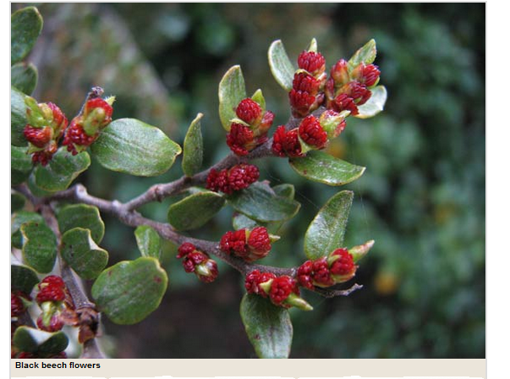
With this potential explosion of pests our native birds are in serious danger to potential drop in population, as explained in paragraphs about pests.
Beech seed is very good for both native and introduced animals. For an example, Kaka only breeds during beech masts. Although the Kaka breeding is a good thing the increased amount of predators will be dangerous for the Kaka trying to breed and extra predator control will have to be undertaken by Doc. The battle for our birds program is the result of this news, Doc is preparing to use aerial 1080 treatment on about a million hectares of public conservation land being treated with aerial 1080 in 2014/15 – about 12% of the land managed by DOC. This programme is expected to go over 5 years’ time period and cost 21 million dollars.
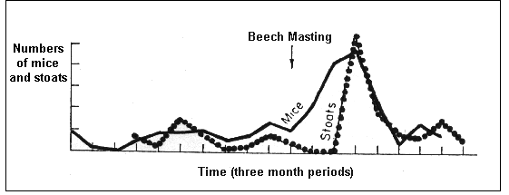
This shows the relationship between a beech mast and the pest populations. Showing the “pest explosion”.

Reason for controlling Ship Rat population
The ship rats (rattus rattus) primary food source is seeds. This year 2014 is a beech mast year which means there will be an abundance of seeds for the rats too eat and they will breed in full force. Although in winter when the seeds start to rot away there will be an excess amount of rats and not many seeds, the rats will find other things to eat, for example the south island robin (Petroica australis australis ). The Robin is in particular danger as the excess number of rats hunting them (mainly their eggs) will have a direct impact on their population.
Rat population has been controlled for protection of natural passerines e.g the South Island robin (Petroica australis australis) by controlling the rat population it gives a chance for the south island robin numbers too increase as there won’t be as many rats too eat the robin eggs in the nesting seasons.
They controlled and monitored rat numbers twice in the mainland island during 2011-12. The first operation in September 2011 (spring) was too control rat numbers before the robin breeding season, the second in April 2012 prior to a partial beech mast.

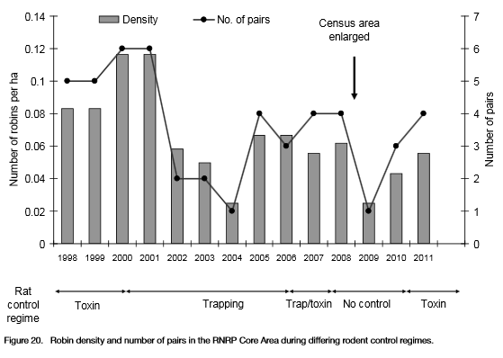
This graph shows the Robin population during certain rat control periods. It shows that the Robin population does the best during periods where rats are being poisoned (1998-2000, 2006-8, 2011-?) The period in which rats were trapped or not controlled the Robin population dropped. This shows the direct effect of Rat population vs Robin. If the rats are not controlled during the beech mast when the seeds run out the excess amounts of rats could severely affect the Robin population.
The poisoning of rats is not continued all year round as it is mainly only needed around nesting season when the native passerines are in danger and also it is not cost effective.
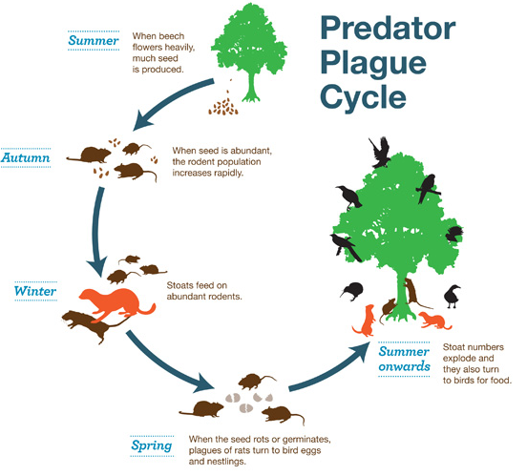
(FIG 1)
This shows the effect the 2014 beech mast could have if pest control isn’t factored in. The rats eat seeds and with surplus food breed lots, the stoats then in turn eat a lot of rats and breed a lot, then when the seed rots or germinates the stoats and rats turn to the bird population for food.
Beech trees generally seed every four to five years but weather conditions over the last two summers - a cool summer followed by a warm one - appear to have triggered a bumper seed or 'beech mast' event. Intense and widespread flowering throughout North and South Island beech forests during spring and early summer has prompted the need for urgent action. The explosion of pests in spring when the seed runs out or germinates will mean the pests change their diet and will prey on native birds and their eggs, aswell as other endangered species such as bats and snails.
Past experience has shown that when a beech mast occurs, it leads to a dramatic rise in mice and rat populations, who feast on the plentiful seed all winter. A single female rat can potentially produce 10 offspring every eight weeks.
Rat control procedures will be undertaken heavily this year as this year 2014 is the year of a beech mast. They control rat numbers with RatAbate in bait stations (diphacinone in a peanut butter matrix) in paper bags in the Philproof bait stations, was used in both operations. The rats are lured by the peanut butter bait and later killed by the poison. They do this once or twice a year.
Info from
http://www.doc.govt.nz/Documents/conservation/land-and-freshwater/land/rnrp-annual-report/rotoiti-annual-report-2011-12.pdf
And Patrina Carter
Stoats
(Mustela erminea)
Mustelieds are trapped approximately 5000 ha to the east and north of Lake Rotoiti. The goal of the trapping is too supress stoat tracking numbers too below 5% too allow successful Kaka breeding (Nestor meridionalis) The 24 traplines have a total of 907 mustelid traps: 815 DOC 200 traps (441 stainless steel/ 372 combination) and 92 DOC 250 traps. Stoat traps are spaced 100 m apart. All traps are single set, baited with hen eggs and enclosed within wooden boxes. The box design is ‘best practice’ length for use in weka and kiwi areas. During the summer and autumn when stoat numbers are high and juveniles are dispersing, trap lines are checked fortnightly. Intervals between trap checks are extended to up to 6 weeks over the winter and early spring when few stoats are present. They also use A24 resetting traps for stoats, they can kill 24 stoats before more gas needs to be put in the traps.
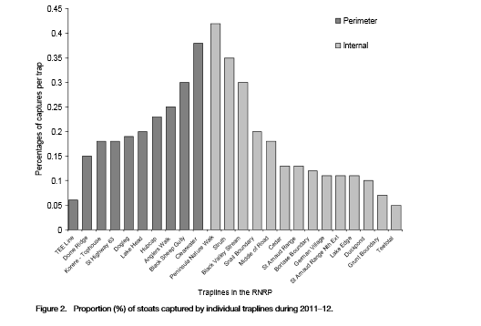
The result of this trapping in 2011-12 resulted in the trapping of 164 stoats, 8 weasels and 4 ferrets.

This graph shows percentage of those stoat captures on certain trap lines, showing where stoats are most present.
DOC can track what the stoat population is doing with tracking tunnels on the forest floor, they set 200 tunnels with meat as bait for stoats and leave them out for three days. The goal percentage is for 5% too show stoat footprints left from the ink pads in the tunnel, 0% being unlikely as reinvasion will always happen in rotoiti. In february 2014 17% of the tunnels in Rotoiti had footprints in them and the comparative forest in Rotorua that has 0 pest control had 37% of their tunnels with stoat footprints. Although the 17% is a lot larger percentage then the aimed for 5% the comparison forest still shows that the pest control in Rotoiti does have a effect on the stoat population.
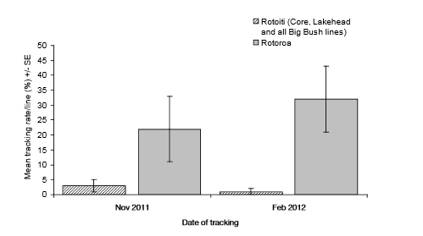This diagram shows the percentage of Stoats tracked in the mainland island vs rotoroa. This shows that docs stoat control is having effect on the stoat population. During 2011–12, mustelid tracking rates were again below 5% within the Mainland Island, highlighting the ability of the form of trapping programme being used to maintain pressure on an invasive predator population. Ongoing adjustments and trials of trap types, trap arrangements and bait types will only increase the ability of predator control programmes to maintain predators at low numbers on the mainland, and possibly eradicate them on islands. It also shows that the stoat numbers are not dropping naturally as the Rotoroa number continues to be large and increasing where no pest control is present,

The stoats population has opportunity to blow up as this year being a mast year will mean increase in food for stoats as shown in (FIG 1) an increase in the rat population will mean more food for the stoats. When the mast expires (seeds run out or rot) the abundance of stoats will eat rats and then turn to the native birds and their eggs for food. The Kaka (Nestor meridionalis) will be in particular danger as the stoats tend to eat many Kaka. The kaka population is monitored by doc in comparison to the number of stoats in an area. In 1991-2000 stoat control was present on the mainland island and during this period there was a 10% fledging (kaka chick) survival rate in Rotoroa whilst there was a 60% survival rate in Rotoiti. The kākā encounter rate survey was continued during 2011–12 (from the beginning of October 2011 through to the end of April 2012). The survey is run in conjunction with the mustelid trapping programme during the regular trap checks on 19 of the 24 trap lines. The other 5 mustelid trap lines are excluded, as Kaka does not live in those areas. They concluded that the stoat trapping has a direct effect on the Kaka population as the kaka encounter rate in 2011–12 was 48.5% higher than that recorded during 2010–11.

WASPS
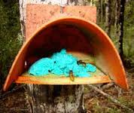
German wasps (Vespula germanica) and common wasps (Vespula vulgaris) The German wasp was introduced with United States aeroplane parts in the 1940s and the common wasp arrived relatively recently but are now widespread.
“The beech scale insect plays a vital role in the food supply for a range of native bird and insect species. The native insect lives in the bark of beech trees drawing off the sap. The insect then excretes sugary liquid drops, known as honeydew.” http://www.doc.govt.nz/conservation/native-plants/beech-forest/
FIG 3
They are a problem in the Rotoiti Beech forest ecosystem as they compete for the honeydew as a food source with other natural birds, lizards and insects. They also eat some natural insects.

The honey dew being a producer provides a high energy carbo rich food source all day everyday which is where a number of consumers find their meals. Honey dew drops provide meals for Tui, Bellbirds, Kaka and Lizards, Wasps also eat the honey dew and this is where the interspecific competition for food starts and some animals end up with not enough food to sustain themselves and their population.
Bait stations are used for Wasp control by Doc, the protein based bait with poison is planted and the workers are attracted to this food source, take it back to their hives and feed it to the queen who feeds it to the grubs and in turn the workers. (workers only take back to their own hives, worker wasps are very loyal.) This means that the poison wipes out whole colonies of Waps and is very effective in terms of pest control. These stations are only used for a short time (warmest week of summer) when the wasps are most active. Doc can monitor number of wasps by counting how many wasps enter and leave a hive, after treatment this is usually 0. After this wasp Treatment Rotoiti national park is mostly wasp free, where the comparative island, Lake Rotoroa is still smothered with wasps. This shows that the wasp control works and it is not a natural decrease of population

During summer 2011-12 there was a wasp control operation that was initiated later in season as wasp numbers appeared to be lower. The observation by Doc was that the toxic bait was successful in reducing wasp numbers, “Wasp activity within the Core Area was observed to fall within a few days of the operation, although there were still some active nests noted in the following months. Preliminary results inside the Core Area also indicated that the operation was successful in increasing the availability of honeydew to native birds, with around an 80% reduction in flight counts of marked wasp nests. Results also indicated that a 71% reduction in the wasp foraging index could be enough to stop wasps having a detrimental impact on the ecosystem. “http://www.doc.govt.nz/Documents/conservation/land-and-freshwater/land/rnrp-annual-report/rotoiti-annual-report-2011-12.pdf

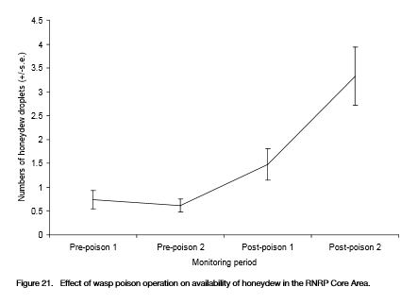
This graph shows the number of honey dew drops on Beech tree’s in the RNRP core area where wasp control was undertaken. This led to the more available food for native bird and invertebrates.
Through wasp control Doc aims to
- Reduce the removal of valuable food sources for native animals from our forests by wasps;
- reduce predation by wasps on native invertebrates and bird nestlings so that the impacts of wasps are insignificant alongside other mortality factors affecting these groups;
- Improve the public’s experience when visiting public conservation land.
-http://www.doc.govt.nz/conservation/threats-and-impacts/animal-pests/animal-pests-a-z/wasps/docs-work/
Because of reinvasion Doc constantly needs to repeat wasp control activities to sustain the forest ecosystem, large numbers of wasps are predicted for the 2013-14 summer.

Possums
The brushtail possum (Trichosurus vulpecula) arrived in 1837 from Australia and since has been huge common pest in new Zealand forests as they eat everything. (buds and flowers, Fruit, Ferns, Bark, Fungi, Invertebrates, Native birds and Eggs, Land snails, Carrion, And also a native plant, Mistletoe. Possums compete with native birds for food and for habitat, thus disrupting the forest ecosystem and also may even impact on native land snails.

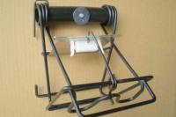
Mistletoe (FIG 5) is particularly susceptible to possum browsing, (Alepis and Peraxilla spp.) And this makes the plant a good tool for assessing possum control.
FIG 4
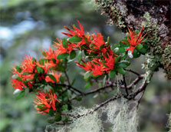
In the core RNRP area where possum control took place the saw an increase in mistletoe about on beech trees. There went from being around 30 to 300 plants in the area. The health of the mistletoe in the RNRP core area was monitored in 2013. Doc found that the overall level of possum browse was low, and the overall health of all plants had improved since the last survey in 2008. Many plants have increased in size and foliage density, this means that the possum control around the RNRP core area is successful in keeping the possum number down and is bringing the native plant back to health. The mistletoe is important to the ecosystem as they are a food source for nectar feeding birds, specifically Bellbirds, (Anthornis melanura).
Fig 5
Fig 5
Bellbirds had developed a technique to twist the unopened flower buds to collect the nectar, and in doing so fertilised the flower. Mistletoe is a favourite food of possums. With most mistletoe browsed-out, bellbirds were deprived of a valuable nectar source. When some plants did recover, the birds had lost the ability to open the buds.
Chew or waxtags are placed around on tree’s to see if possums are in the area, this show’s DOC where they need to take measures in controlling the population or if certain area’s do not provide habitat for possums.

In 2011-12 Possum control was maintained on the Snail, Grunt, MOR and Lakehead mustelid trap lines. All traps used were the sentinel kill traps (FIG 4) and they were baited with ‘smooth in a tube’ and ‘possum dough’ which were applied on alternate traps along lines. As a result one hundred and twenty possums were caught in 2011-12. Trap lines near the south of the Core Area caught the highest number of Possums. This is due to the fact that no Possum control exists south of the Mainland Island, so there is likely to be a continuing high rate of re-invasion in this area.
Numbers of caught possums in 2011-12 was consistent with number caught in previous years, 149 in 2010–11 and 101 in 2009–10. The increase in certain years is due to increased trapping effort and possibility of trapping in areas that has had no previous possum control.
“A wax tag monitor was conducted for the first time recently in Big Bush to gain some baseline data from this historical Animal Health Board (AHB) control area. Two years ago AHB reduced their possum control in Big Bush and this may result in possum numbers gradually increasing in this key kākā breeding area.
The monitor recorded a possum activity index of 14% — a moderate result which indicates there are pockets of possums which could affect nesting kākā. New Sentinel possum traps have now been positioned along existing stoat trap lines.”
http://www.doc.govt.nz/about-doc/news/newsletters/revive-rotoiti/autumn-and-spring-2013/#possum-monitoring
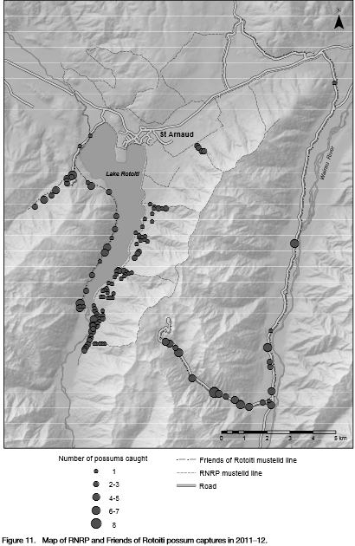
This map shows trap lines where RNRP and Friends of Rotoiti trapped possums during 2011-12, around the lake head seems to be where most possum captures were.

The Report.

The work Doc does in Rotoiti with controlling pests has not just effected the ecology of the forest ecosystem by helping native species flourish and return to as close as possible to the original state. But the work has also had Social, Economic and Cultural effects.

By creating bush tracks and huts throughout the forest the Forest has become a popular tramping and hiking area where people can walk through a close to native forest and experience the native wildlife of New Zealand first hand. People experience this and talk, spreading the word of what Doc has done and in turn attracting more tourists. 15 years ago the Lake Rototit national park was full of wasps, so many that people couldn’t go enjoy a picnic without fear of being stung by many wasps. Now that the wasp population is controlled people are able to enjoy walks and picnics without having to worry about wasps. This is a huge attraction and a lot more people come to this area then they would have when wasp population was high. Also with the volunteer exchange and the huge range of things one can volunteer to do this attracts Uni students studying conservation sciences and then by talking to their peers bring more volunteers to the area and help Doc get more work done. People talking about the Lake Rotoiti conservation projects will show the significance to people about the work they are doing and this may draw attention from groups with money such as government or a “mysterious rich family”. This may bring added funds to the revive Rotoiti project and more work will be done.

The work that Doc does affects the economy in a number of ways. The Lake Rotoiti bush walks and tramps are very popular and attract a lot of tourists to the area to walk through the expanse of native bush and native species whilst enjoying a good tramp. This means that there will be more people in the area maybe staying in nearby hotels and this will bring money to the community. It will also raise the awareness and importance of native bush life to people who were once unaware and there may be more volunteers or people trying to make a difference. In turn the number of people coming to these area’s will see the difference between tramping through a national park where the native wildlife is abundant and pests are controlled compared to the normal tramp where not near the same amount of wildlife will be spotted. People talking about this will greatly affect tourist numbers and a lot more money will be poured into these projects.

The conservation projects helps save the culture of New Zealand. The Kiwi is iconic to New Zealand, a Taonga (treasured species in Maori) but in forests where pests have been introduced the Kiwi is threatened and without pest control the species are on a population decline. “Kiwi was once more abundant and widely distributed throughout New Zealand than they are today. The overall rate of decline for kiwi populations not part of conservation programmes is estimated to be three per cent per year for brown kiwi, and two per cent for great spotted kiwi and tokoeka. All populations of the remaining species are under management. In 2008, the number of kiwi remaining was estimated to be approximately 72,600.” http://www.doc.govt.nz/conservation/native-animals/birds/birds-a-z/kiwi/facts/
Species :
- Brown kiwi (Apteryx mantelli)
- Rowi (Apteryx rowi)
- Tokoeka (Apteryx australis)
- Great spotted kiwi/roroa (Apteryx haastii)
- Little spotted kiwi (Apteryx owenii)
Kiwi was to become extinct from forests it would greatly affect NZ culture as it would show the iconic native bird could only survive in captivity and would damage the reputation of New Zealand forests. It was shown that the kiwi was of cultural significance when the Kiwi was reintroduced back into the mainland island and many Maori people turned up to watch it.
Not only Kiwi is at danger, this year being a beech mast means many endangered bird species are at risk of extinction. If any native bird species were to go extinct due to the state of New Zealand forests becoming unsafe for our native animals it would show that our native forests our no longer ‘ours’ that they had been taken over by the pests introduced from other countries and they no longer harbour what’s iconic to our culture.
Rotoiti’s work to protect these birds and try returning this forest close to its natural state not only protects these birds and native animals but also protects our culture as these native birds represent us as “Kiwi’s”.
Doc is prepared to use aerial 1080 treatment during 2014-15 to combat the explosion of pests and help protect the native species.

Information sourced From Doc worker Patrina Carter.

