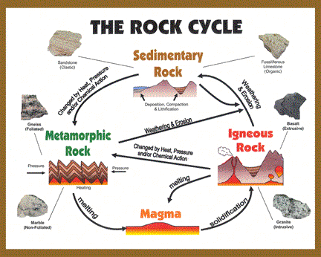

Name

|  |  |  |
| --- | --- | --- |
| Name | Type | Features |
|  |  |  |
|  |  |  |
|  |  |  |
|  |  |  |
|  |  |  |
|  |  |  |
|  |  |  |
|  |  |  |
|  |  |  |