UV radiation: sunburn vs vitamin D
Source NIWA: http://www.niwa.co.nz/news-and-publications/publications/all/wa/17-1/risks
The health risks of excessive UV radiation are well known. New Zealanders have among the highest skin cancer mortality rates in the world, mainly from melanoma.
Unlike more tropical climates, here we can comfortably sit outdoors in direct sunlight for long periods, and for those with paler skins especially, sunburn is still a common complaint.
Sunburn is a known risk factor for developing melanoma, and for many years we have been advised how to protect ourselves from sunburn during the summer, when UV intensities in New Zealand reach values that are 40% more than at corresponding northern latitudes. However, there is another side to the UV story.
When our skin is exposed to UV, our bodies synthesise vitamin D, a key component for good health. It turns out that during winter many New Zealanders have sub-optimal levels of vitamin D, which suggests that in winter our UV exposures may be too low. People in the south of the country and those with darker skins are at greater risk of having sub-optimal levels of vitamin D during the winter months.
What is the problem with vitamin D deficiency?

Work out the UVI (UV index) from your shadow…..

My height ____________ ______
My shadow ____________ ______

Shadow length multiplier :
shadow / height = _________ / _________ = __________
UVI (from table below) ____________
What does this mean for the time you should be in the sun

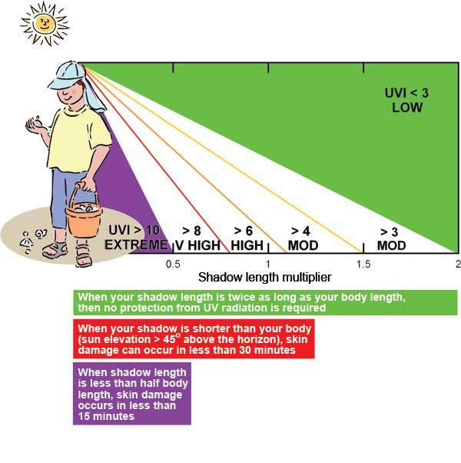
Approx SZA ( ° ) | UVI | Approx shadow multiplier | Time for sunburn (minutes) | Time for 1000 IU Vit D (minutes)
 |  |  |  | Full body (100%) | Face & hands (10%)
70 | 1 | 2.7 | 180 | 20 | 200
63 | 2 | 2.0 | 120 | 7.7 | 77
57 | 3 | 1.5 | 60 | 4.3 | 43
53 | 4 | 1.3 | 45 | 3.0 | 30
50 | 5 | 1.2 | 36 | 2.3 | 23
47 | 6 | 1.1 | 30 | 1.9 | 1.9
42 | 7 | 0.9 | 26 | 1.5 | 15
38 | 8 | 0.8 | 22 | 1.3 | 13
36 | 9 | 0.7 | 20 | 1.1 | 11
32 | 10 | 0.6 | 18 | 1.0 | 10
24 | 12 | 0.4 | 15 | 0.83 | 8.3
0 | 15 | 0.0 | 12 | 0.67 | 6.7
To use the table, start by using your shadow to estimating the solar zenith angle (SZA), which is 90˚ at sunrise or sunset and 0˚ for overhead sun. Exposure times are for light skin. For darker skin, multiply by 2 (for Māori/Polynesian) or by 5 for black skin.
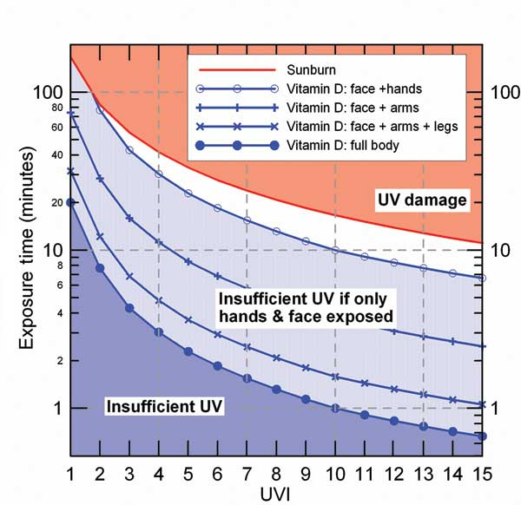

In summer, when the UVI is greater than 10, our bodies can produce optimal vitamin D from a few minutes of sun exposure to the face and hands (and about a minute for full body exposure). But exposure times should be less than about 15 minutes to avoid sunburn. When the UVI equals 3, skin damage occurs after about an hour, but optimal vitamin D can still be produced in a few minutes if at least the face, arms, and legs are exposed. Even during winter in southern New Zealand (when UVI reaches only 1 at midday) there should be sufficient UV radiation available to maintain vitamin D, though we’d need to expose larger areas than hands and face alone.
HOW it works
