what we study in L2 EARTH &Marine Science
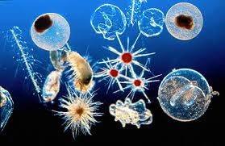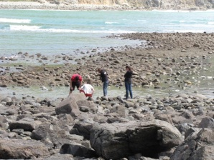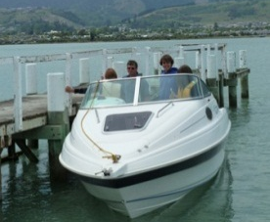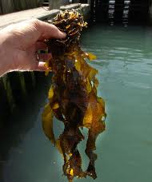
Course co-constructed from the likes of:
Plankton: theory, catching and microscope viewing
Ecosystems around Nelson: Oyster Island restoration
Geology: local geological processes, eg Cyclone Gita erosion, boulder bank,
Extreme Earth Events: earthquakes, volcanoes, tsunami
Mud: what is in it, who eats it, how important is it
Adaptations: reproduction of fish, sharks, shellfish, crayfish
Astronomy: getting to Mars and living there, or?
Seawater Chemistry: theory, practical investigations
Extreme Environments: life in Antarctica- Emperor Penguins
Resource Management: NZ fishing industry, salmon farms
