what we study in L3 EARTH &Marine Science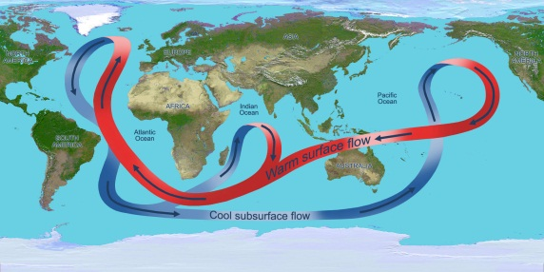 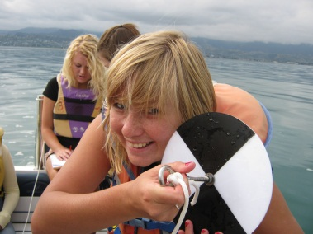 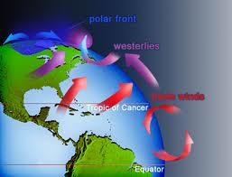
Course co-constructed from the likes of:
Tasman Bay: the impact of erosion on the water in Tasman Bay
Earth Science Issue: Cobb Valley mine / Marlborough sounds salmon
Oceanography: ocean currents, waves, tides - global & local
Atmosphere: the structure and behaviour of the atmosphere
Astronomy: the study of an aspect of astronomy
Shaky AF: dating quakes on the alpine fault, how do they do it?
Topic of choice: lots of opportunities for work on something of interest

