what we study in L3 Biology
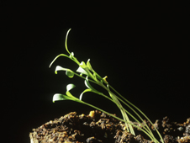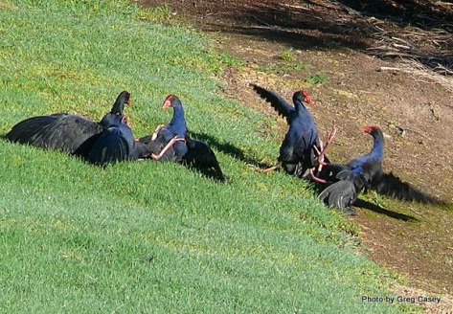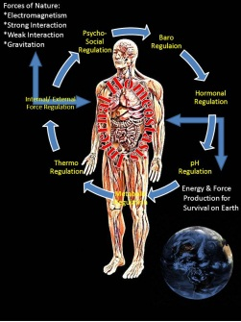
Plant Responses: how plants respond to their environmental
Animal Behaviour: how animals respond to their environmental
Homeostasis: how animals (humans) maintain a stable internal environment
Research Project: an aspect of mollusc biology (your choice), at the Cawthron Aquaculture centre
Evolution: processes leading to speciation
Human Evolution: trends in the evolution of our species
Biotechnology: manipulation of genetic material and its implications
