Lesson 1: Health Science
Ako:
- Learn about science this year
- Learn about whakapapa (Health Science taster lesson)

Hua:
- Know the structure of the year
- Understand the idea of whakapapa
- Complete whakapapa chart
- Extract DNA

Yr 10 Science…. Going modular
We have 4 modules for you to chose from…. You will do do 2
- Tātai Arorangi
- Engineering
- Health science
- Planet Earth and its history

Whakapapa…. Not just my ancestors….a collection of: stories, lives, experiences, mahi, deeds, mahi
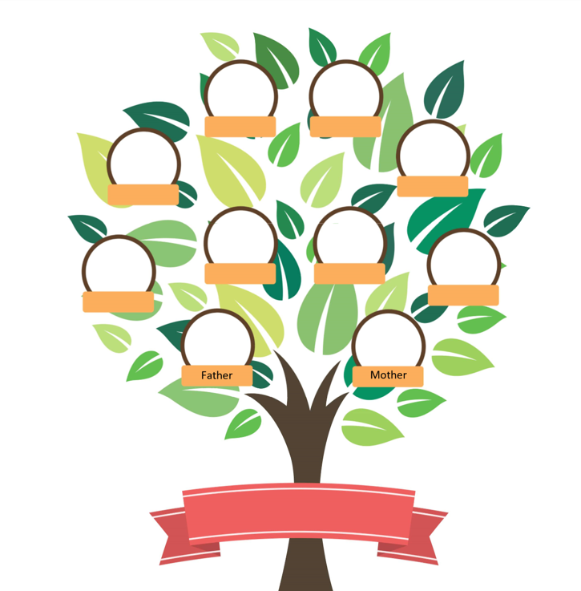

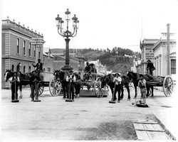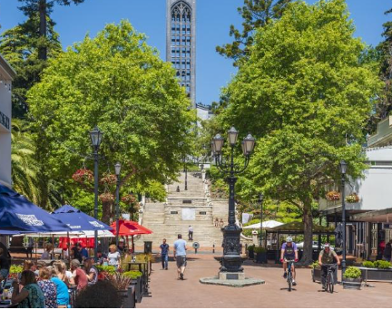
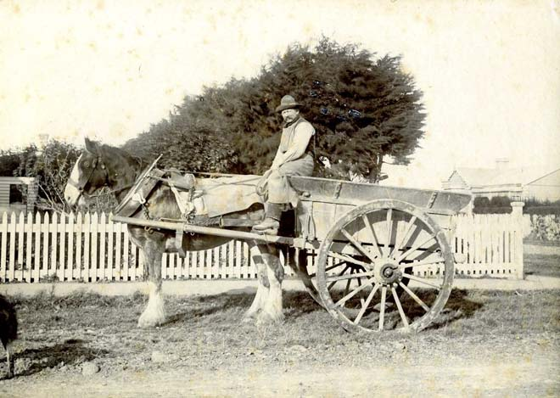
Lesson 2: Earth Science
Ako:
- Learn about thinking with evidence

Hua:
- Figure out what we ‘know’ about the Earth
- Use evidence to figure out what is in the cannisters
- Make a ‘fossil’

What do we already know
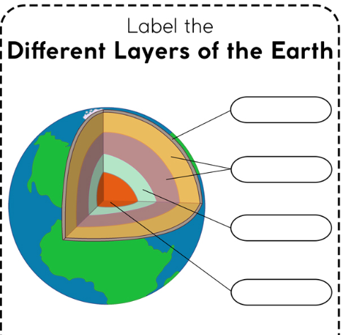
Are we correct?
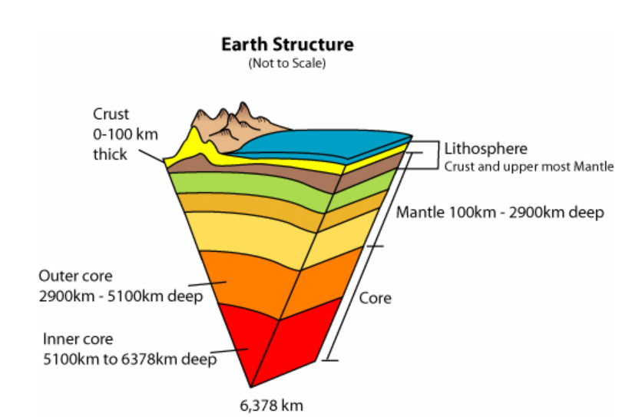
How do we know…..

https://en.wikipedia.org/wiki/Kola_Superdeep_Borehole
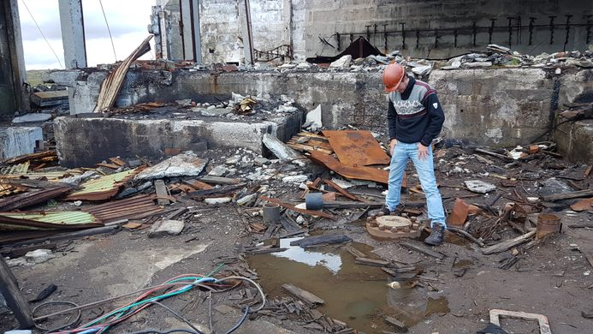
Kola got 12 000 m deep……
Earth: surface to centre is about 6000 km (use 1 km = 1 mm) lets see how deep the drill went

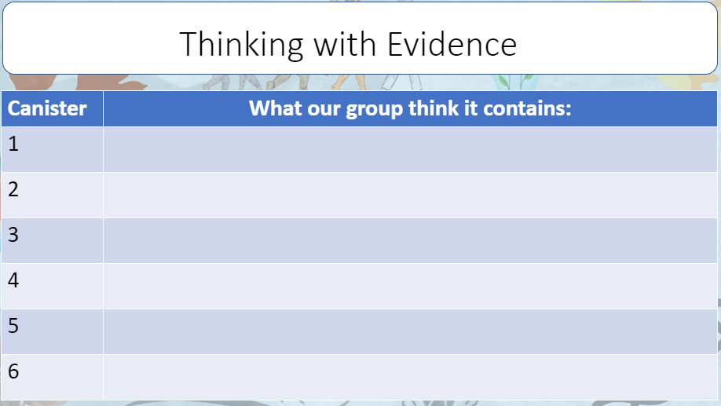

Engineering

